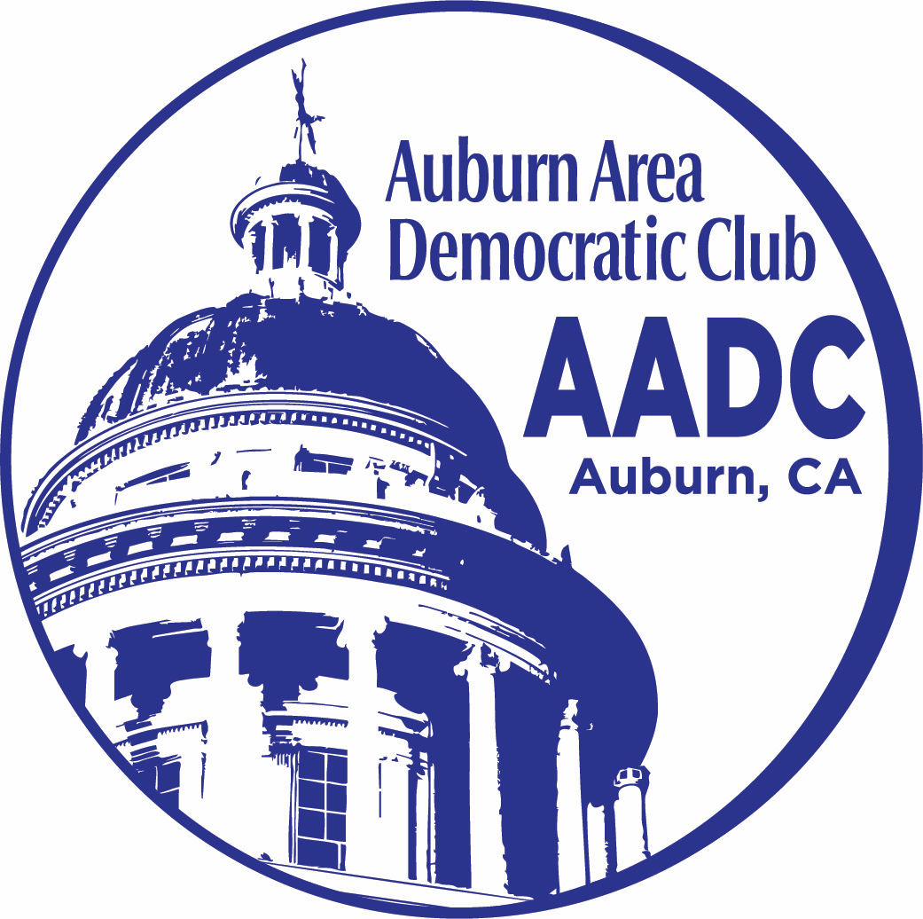
Auburn Area Democratic Club
161 Palm Ave, Suite 8 & 9
Auburn, CA, 95603

AADC E-Board Meeting – Apr 17, 2026
Officers Present:

President: Cindy Engen
Vice President: Don Ferguson
Controller: Judy Gomez
Secretary: Joan Jernegan

Committee Chairs and Co-Chairs Present:
Membership Co-Chairs: Sandy Floyd and Edlene McKenzie
Community Events Chair: (Vacant)
Communications Chair: Emily Gaben for Susan Roughgarden
Voter Registration Co-chairs: Leslie Moonshine and Gail Bartlow
Fundraising: (Vacant)

Absent:
Susan Roughgarden

Guest(s) Present:

I. Call to Order

A quorum being present, the meeting was called to Order by President Cindy Engen at 12:32 p.m.

II: Introduction

Cindy Engen, President
Welcome & Housekeeping
No housekeeping matters at this time.

President Engen asked for comments on the last General Membership Meeting.

III: Approval of Minutes

- Feb 13, 2026 E-Board Minutes
MOTION: Vice President Ferguson moved to accept the March 13, 2926 E-board minutes. 2nd. Minutes were approved by a unanimous vote.

IV: Officer Updates
President Cindy Engen reported that the next General Membership Meeting will have the theme of “Understanding who we are in our Society”. Speakers are:
Judge Dixson – The legal system and my experience with it. John Bowman is writing an article on it for The Auburn Journal Don Ferguson, PHD – Surviving the Politics: The Amazing Stress Response Cindy Engen -How to have conversations with strangers Neva Parker – How to help get a candidate elected

- Reward for pellet shooter. President Engen reported that she has been advised that AADC is not allowed to raise a reward. Ed Koons has opened a separate account for reward donations. The total is approximately $3,000 to date.
- President Engen asked for suggestions for the next speaker for General Membership Meeting on June 4th. Perhaps on Project 2025? Also, for July 9th. Requested that Susan be asked for suggestions by Emily.

Perhaps the Lincoln Democrats will help us staff it Susan’s request that we pay for a table at the PCDCC fundraiser was not approved by the EBoard.

V. Officer updates
- Vice President Ferguson reported that Coffee & Conversation are proceeding, with about 12 attendees per week. Vibrant discussions are held which sometimes break down.
- The Volunteer List is to be updated on the website. More volunteers might agree to have their names on the list as backups, rather that regularly responsible.

- Controller Judy Gomez
Due to technical difficulties, the Quarterly report will be shared by email at a later date.

- Secretary Joan Jernegan The Scholarship Committee has members volunteering to do the presentations: Edlene McKenzie, Mike McGinnis and Lucy Clark will be attending the ceremonies at Placer High School and Colfax High school on May 11 and May 18, 2026. Someone needs to plan to take a photo for posting on our web page after the distribution of awards.
Leslie Moonshie MOVED and it was 2ND to increase the Scholarship awards to two $1,000 awards for 2027. The motion was passed unanimously.

- Membership Committee Chairs – Sandy Floyd and Edlene McKenzie
- Preparations for Membership drive on Saturday April18 are underway. They will set up at 11:00 am, have swag, raffle items, snacks. Will only request reimbursement from AADC funds for Tablecloth, paper cups and plates. Hoping for 18 new members. Need to follow up when new members come to meetings.
- Membership perk – Lilivas Williams has offered to will help us obtain a discount card for local merchants to offer to all members. No response has been received to follow up contacts.

- Attendance at the April Membership Meeting was 70 attendees, composed of 48 members and 22 guests.

VI. Committee Chairs

Gail Bartlow and Leslie Moonshine, Voter Registration

- Sierra College Earth Day 4/23 –we do have volunteers. Constitution giveaways have been purchased.

- Hip Hop Congress Earth Day 4/25 –we have volunteers, but afternoon volunteers may be responsible for takedown.

- When we canvass with Neva, unknown if we have forms for voter reg.

- Communications Committee Chair – Emily Gaber filling in for Susan Roughgarden, on vacation.
- Events happening- website lists events from other organizations. Indivisible, Gold Country Food.

- VII. Committees without chairs
- Fundraising

- Gail handling Poll Workers event – sending info on fingerprinting. Has more than enough volunteers. Currently getting Livescan fingerprinting and signing up for training.

- Plan for picnic August 29th. Cindy has reserved Auburn Recreation Park, for lunchtime. There will be no auction – maybe raffle. Costco makes sandwich trays at good value.

- After the election, in early June, we will hold a get together for a club/friendship lunch or dinner. El Tapatio will give us 20% of proceeds. No weekend dinners.

- Community engagement

- We are partnering with other groups – Young voters – Placer Community Unite for Students (PCUS) outreach. Dorian is representing Placer High School.

- Placer Pride event May 16 – need volunteers to work this?

- Placer Country Fair is Sept 10-13 – Gold Country Fair is June 25 – 28 PCDCC has offered to pay for space for the latter, if AADC will staff a table. Perhaps the Lincoln Democrats will help us staff it.
- Juneteenth is observed on June 23rd.
- Kidapalooza will be on May 14, 2026 Leslie Moonshine and Gail Bartlow worked at last year in recreation park. Young children and their parents participated. It.

VIII. New Business
- Zoom call late April early May with Insurance candidates –need to do through PCDCC

IX. Adjournment at 2:34pm

